The 30th International Youth Forum (IYF)

Program Briefing Paper

April 2019

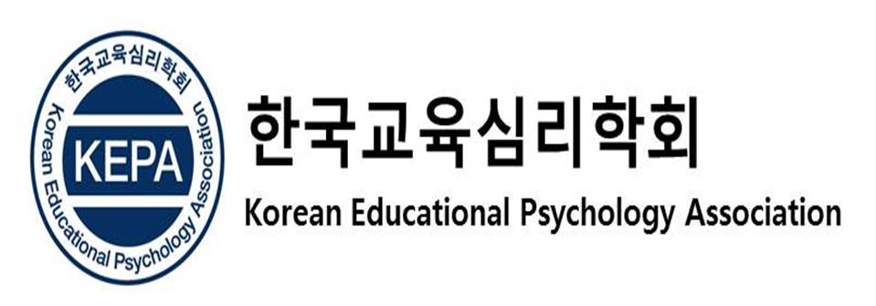
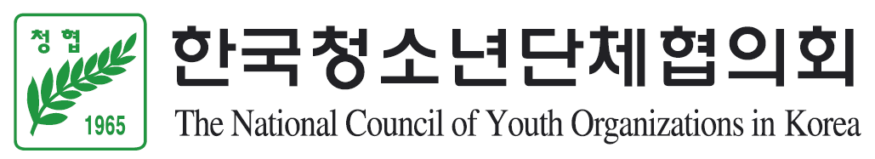

Call for Participants
The 30th International Youth Forum (IYF)

1. Objectives
A. To increase youth’s understanding of global issues, offering an opportunity to tackle them
and to find alternative ways or solutions.

B. To improve cooperation and enhance mutual understanding among youths across cultures
and nationalities.

C. To spread goodwill around the world and to build interactive global citizenship through
networking among youths.

2. Date and Venue
A. Date: 16th ~ 23rd July, 2019

B. Venue: Seoul, Republic of Korea.

3. Theme
Inclusion and Inclusiveness: Shared Vision of Youth for Local, National, and Global Village
Inclusion at large stands for embracing populations with disabilities and other minorities while the inclusiveness further accentuates the current state of supporting and accepting hidden handicap subgroups (e.g. slow learners) and socially sensitive issues in media and our environment.

* 3 main topics and sub-categories:
A. School Education and Youth Activities for Inclusion and Inclusiveness
- Sub-category 1. Inclusion in School: Diversity and Inclusive Education
- Sub-category 2. Effects of Community Sharing for Inclusion: Local and Global-level Volunteer
Practice
- Sub-category 3. Action Plans for Connecting School Education and Community Activities for
Inclusion and Inclusiveness

B. Roles and Assignments of the Media for Inclusion and Inclusiveness
- Sub-category 1. Exploring Discrimination Types and Policies through the Lens of Media
- Sub-category 2. Light and Shadow of the Internet and SNS Usage
- Sub-category 3. Effects of the 1st Person Media and Youth Participation Plan

C. Exploring of the Inclusion Environment Designs
- Sub-category 1. Homo Ludens (playing humans) Youth Environment for Life: Inclusive
Environment Design for Play and Relaxation
- Sub-category 2. Inclusive Planning for Community Work / Occupation / Cultural Space
- Sub-category 3. Exploration of Inclusiveness and Practicality through Universal Design

※ Note
- All participants will be assigned to smaller working groups under the each sub-category.
- All participants should indicate which topic you want to discuss in the application form.

【The Background of this year’s Theme】

In this global world wherein cultures and nations rely upon one another reflecting true hybridity, attaining superlative global citizenship is at its highest demand especially on youths for the world’s future peace and harmonious growth.

Acknowledging and understanding that youths themselves are the main problem solvers, increasing their capabilities and proficiency in handling issues of multiculturalism, inter-connection, inter-dependency by providing hands-on educational opportunities of adaptation and transformation skills should be highly encouraged.

Therefore, this year’s forum will offer a uniquely designed opportunity to the youth participants from the globe in order to gain, share, and contribute their knowledge and experience relating to three main topics of the theme “Inclusion and Inclusiveness.”

What is your I.D.E.A.? Our forum, in the process, will scrutinize Inclusiveness, celebrate Diversity, learn about Equity, and produce Action plans to heighten the responsibilities of global citizens.

The youths enrolled in the forum will actively utilize considerate, interactive and participative approach and are expected to contribute their talents and services at the local, national, and global level of society.

4. Organizers
A. Host: The National Council of Youth Organizations in Korea (NCYOK)

B. Organizers: The National Council of Youth Organizations in Korea (NCYOK)
Korean Educational Psychology Association (KEPA)

C. Sponsor: The Ministry of Gender Equality and Family, Republic of Korea (MOGEF),
World Assembly of Youth (WAY), Asian Youth Council (AYC)

5. Participants
A. Overseas participants: 150 delegates

B. Korean participants: 30 delegates

6. Qualifications for Participation
A. Youths between the ages of 18 and 26 who have a strong interest in the topics

B. Youths who have a good command of English (official language)

7. Financial Aid for Foreign Participants * provided on the last day of forum
A. 600,000KRW (about 560USD) grant will be provided for travel cost (airfare) to the participants
from Africa, Oceania, Europe, and American regions.

B. 300,000KRW (about 280USD) grant will be provided for travel cost (airfare) to the participants
from Asian countries.

* For More Economically Developed Countries (MEDCs) in Asia, participants from these
countries will not be considered for a travel grant (should cover their own travel expenses).
* MEDCs in Asia: Brunei, China (Hong Kong), Japan, Malaysia, Singapore (6)

※ Note: The following applicants will be first considered
- who submit a good essay on the theme and topics
- who are studying the fields related to the theme and topics
- who are engaged in the fields related to the theme and topics
- who can afford to cover own travel cost

C. Host country will cover the expenses of accommodation, meals, and local transportation during
the forum.

8. Application and Required Documents
A. Application closing date is May 31 (Fri), 2019 (Korea Time)

B. Applicants need to submit:
1) A completed application
2) 3 English essays (refer to the application form)

C. Please submit the application on our website (http://eng.iyfkorea.org/).

9. Contact Information
- External Cooperation Team of NCYOK
- Tel: +82-2-2667-0810~1 / +82-2-2667-0875
- Fax: +82-2-2667-0479
- E-mail: yul0918@koreayouth.net

10. Program Schedule

July  2019 | Activities | Remarks
16th  (Tue) | - Arrival / Registration  - Opening Ceremony  - Ice Breaking | ※ Accommodation  - International Youth Center
17th  (Wed) | - Orientation (Safety Education)  - Survey & Introducing the Forum  - Case presentation  - Special Lecture  - Discussion Time 1
18th  (Thu) | - Discussion Time 2  - Experiencing Program  (Korean Universal Design Center)
19th  (Fri) | - Discussion Time 3  - Cultural Exchange Program (Global Village)
20th  (Sat) | - Discussion Time 4  - Compilation of the Discussion  - Final Presentation  - Youth Night (Networking Program)
21st (Sun) | - Korean Cultural Experience
22nd (Mon) | - Video & Photo Collage Presentation  - Closing Ceremony and Farewell Dinner  - Survey
23rd  (Tue) | - Departure
- The above schedules are subject to change.

