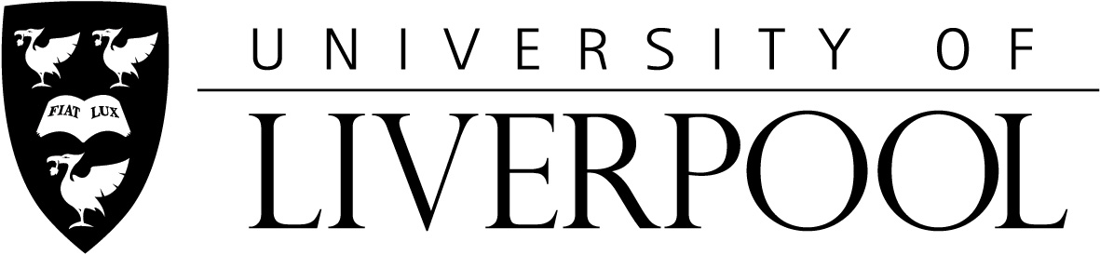

HODGSON LAW SCHOLARSHIP APPLICATION FORM 2021/2022

This application form should be used to apply for the Hodgson Law Scholarship at the University of Liverpool.

For electronically completed forms, this form and attachments should be in doc., .docx, or .pdf format.

For forms completed in print, the form must be filled in block capitals and black ink.

1. | Title: | Mr / Ms / Miss / Mrs / Other (please specify)∗
2. | Family Name:
3. | Other Names:
4. | Date of Birth:
5. | Gender: | Male / Female∗
6. | Country of Birth:
7. | Nationality:
8. | Address for Correspondence:
9. | Email Address:  Please write clearly
10. | Full name of programme  applied for: (e.g. LLM - International Human Rights Law)
11. | Application Reference Number / Student Reference Number

12. | Please give details of your education and qualifications below:  Both school and university qualifications
Institution  Eg. St Thomas’s College, Calcutta / Chulalongkorn University, Thailand |  | Dates attended | Qualifications (with exam board )  e.g. CBSE Higher Secondary School Certificate / Bachelor Degree in Economics | Grade/GPA  e.g. 85%/ CGPA 3.5

13. | Current English Language qualification (please tick): | IELTS  TOEFL  Other (specify)  …………………. | - Score…………………………….  - Score…………………………….  - Score…………………………….  ……………………………………..

14. How did you find out about the Hodgson Law Scholarship? (eg. University of Liverpool website, or Hodgson Law Scholarship website, or Facebook, or other?)

…………………………………………………………………………………………………..

15. Declaration by the Applicant:

I confirm that the information given in this form is correct and complete, to the best of my knowledge, and that I have read and understood the conditions of eligibility. I understand that this award may be cancelled if my fee status changes. I also understand that I may be deprived of this award and required to repay to the University any sums paid or credited to me in respect of this award if the information that I have given is subsequently shown to be false or misleading.

Signature: ……………………………………………………. Date: …………………...

Attachments Checklist:  For electronically completed forms, attachments should be in *.docx or *.pdf format.  □ Academic Transcripts & Certificates  □ Evidence of English language ability  □ Certified copy of Birth Certificate  □ Bachelor’s degree certificate (When available)  □ 2 references (Academic & Character)  □ Essay of application | You MUST send all the supporting documents on this checklist with your application form. We cannot accept incomplete applications.

Deadline – 1st May 2021
For ease of processing please ensure that full paperwork for consideration for the Hodgson Law Scholarship is submitted to Dr. John Tribe, Senior Lecturer in Law, School of Law and Social Justice, University of Liverpool L69 7ZA (email Address: hodgscho@liverpool.ac.uk) by 1st May 2021. Please note that you only need to send one application.

∗ Delete as appropriate
Please turn over

